ASSIGNMENT 04
Name: Maryam Rehan
Course: Digital Marketing
Instructor: Sir Qasim Raza
TOPIC: Content With Inspiration
Discussion Topic: Cybersecurity Awareness for Students
Introduction:
Cybersecurity is the practice of protecting computers, networks, devices, and personal information from online threats. Students use the internet every day for education, communication, banking, and social media. This makes cybersecurity awareness important for protecting personal information and avoiding cyberattacks.

Why Is Cybersecurity Important for Students?
Students can become targets of cyberattacks because they frequently use websites, emails, social media, and online learning platforms.
- Protect personal information
- Prevent malware infections
- Identify phishing scams
- Secure online accounts
- Stay safe while browsing

Common Cyber Threats:
1. Phishing:
Fake emails or messages designed to steal passwords or personal information.
2. Malware:
Malicious software that can damage devices or steal information.
3. Weak Passwords:
Easy-to-guess passwords can allow attackers to access accounts.
4. Fake Websites:
Fraudulent websites can steal login and payment information.
5. Social Engineering:
Attackers manipulate people into revealing confidential information.
Inspiration:
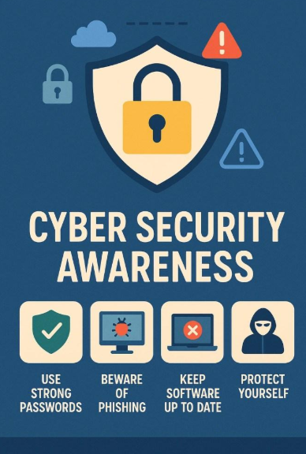

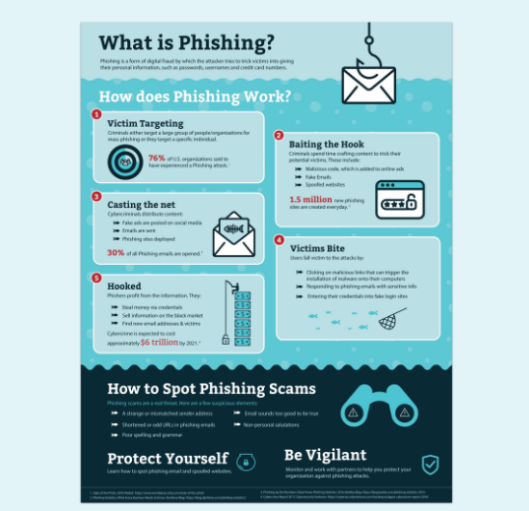

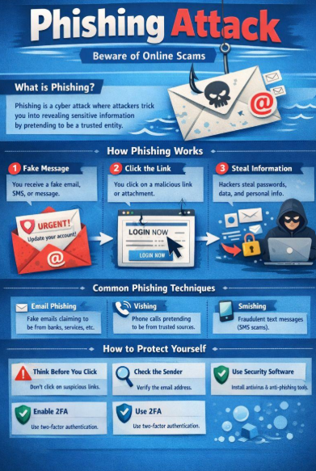
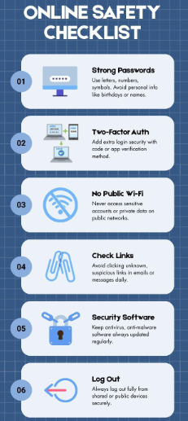
Safety Tips:
Use Strong Passwords:
Create long and unique passwords for different accounts.
Enable Two-Factor Authentication:
Use an additional verification method whenever available.
Think Before You Click:
Don't click suspicious links or unexpected attachments.
Keep Devices Updated:
Install security updates for your operating system and applications.
Protect Your Personal Information:
Avoid sharing sensitive information with unknown people or websites.
Phishing Example:
URGENT! Your Account Will Be Closed
Dear Student,
Your account has been selected for verification. Click the link below immediately to prevent your account from being suspended.
[Verify Your Account]
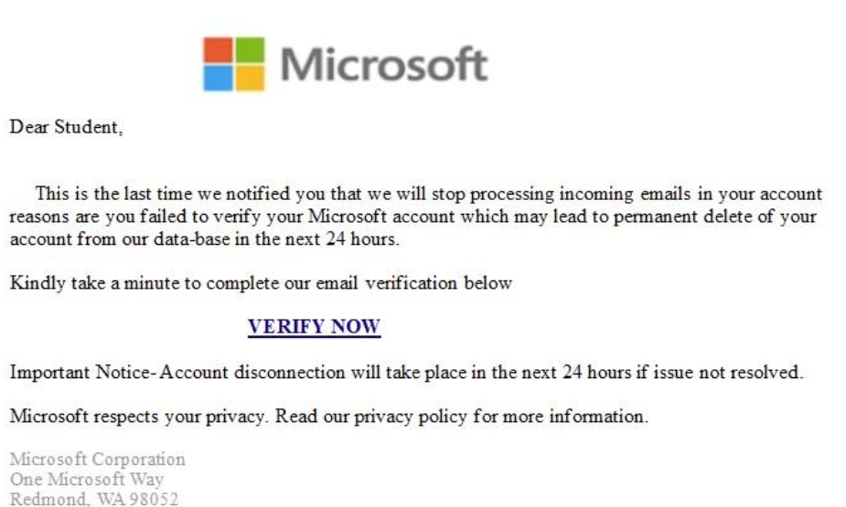
Strong Password Technique:
Use uppercase + lowercase letters.
Add numbers.
Use special characters.
Avoid names and birthdays.
Don't reuse passwords.
Think Before You Click:
STOP
Don't immediately click.
THINK
Were you expecting this message?
CHECK
Verify the sender and website address.
THEN ACT
Only continue when you are confident it is legitimat.
Conclusion:
Cybersecurity awareness is essential for students because every day online activities can expose them to different cyber threats. By using strong passwords, identifying phishing attempts, protecting personal information, and practicing safe browsing habits, students can significantly improve their online security. Staying informed and thinking carefully before clicking can help create a safer digital environment.

